Air Conditioner Project
Project Lab Report
Glenna Vasquez

5/29/2013
Period 2
Physics

Introduction:
- Create and construct an air conditioner out of recycled materials.
- Display all the important parts of the air conditioner.
Standard:
- Heat and thermodynamics
Objectives
- Plan, design, modify and construct an air conditioner model that clearly shows its important parts
- Trace and explain how the air conditioner works
- Relate air conditioner to the laws of thermodynamics.
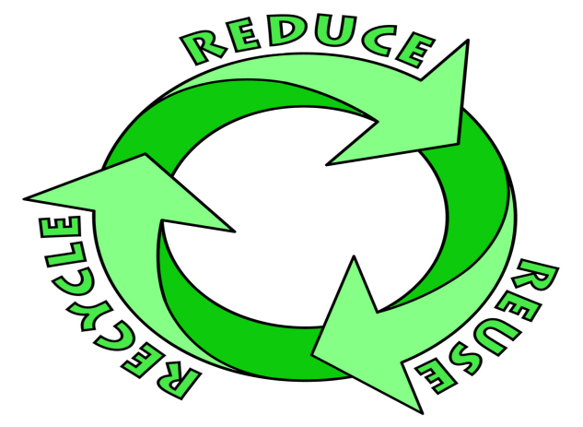
Materials:
- Recycled materials
My materials included:
- Foam board
- Hot glue gun
- Paper
- Straws
- Soda can
- Box cutter
Procedures
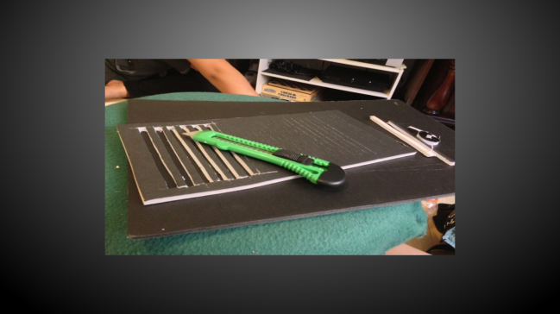
- Gather up all of the materials
- Cut the foam board
- Cut slits into the foam board
- Glue all the boards into placer to form a box shape
- Make a bottom
- Put all of the other parts into the box, to make it look like an air conditioner.

Plan and design:
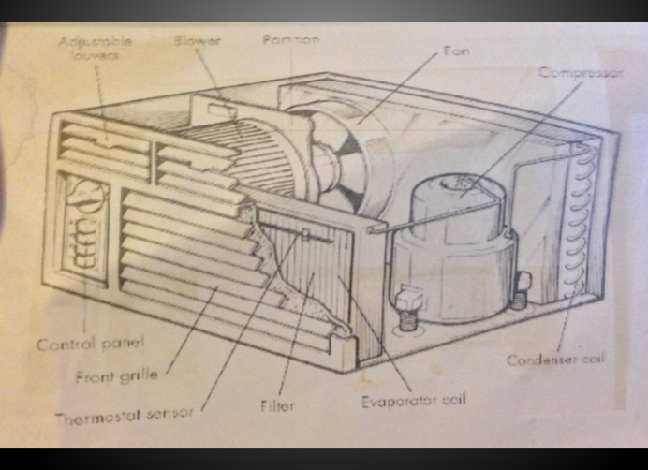

Final Product:
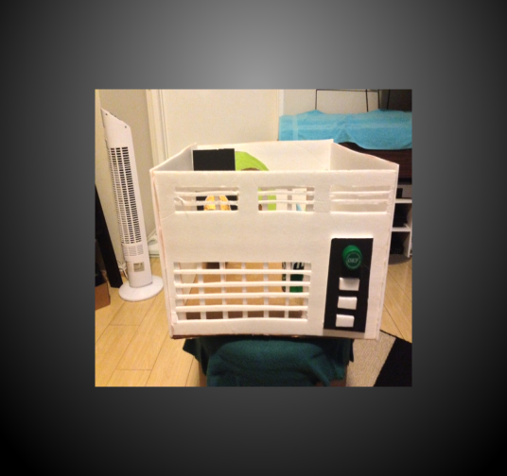
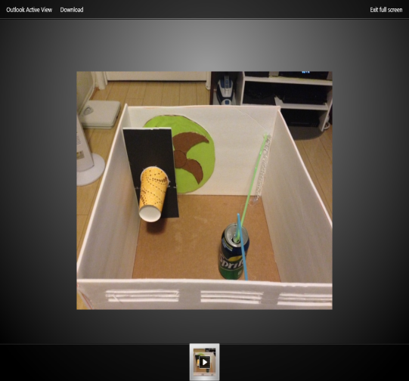

Summary:
We were to build an air conditioner that was make out of recycled materials and make sure toah it showed all of the important parts to the air conditioner.
Reflection:
- This project was way easier than the Popsicle stick house.
- The materials were hard to cut and put together
- All of the recycled materials were simple to find.
Global relevance:
Air conditioners are used almost by everyone; in your homes, in your cars, as a means to stay cool in the summer time.
They use up a good amount of energy and are included in your electricity bill when used.
When you use your air conditioner more than it should be it increases energy usage, especially in the summer when everyone else is also using it. That can lead to further damage in the ozone lair and cause an increase in pollution.

3 safety lab rules
- Don’t point the hot glue gun at anyone
- Don’t play with anyone else’s materials or project
- Don’t run with scissors

